Northwest Syria Cash Working Group Earthquake Response Bulletin

This is a PDF of an online report. Click [here](https://northwest-syria-cash-working-group.github.io/cash_reporting_20230915/) to access it

21 September, 2023

Table of Contents

# 1. MPC response overview

As of **15 September 2023**, a total of **849,830** persons or **169,101** families have been reached by MPC interventions.

A total of USD **27.3 million** has been disbursed by **28** implementing agencies in **266** communities across **35** sub-districts.

*Only beneficiaries who have received at least USD 100/family/month have been included; excludes sector-based activities such as non-MPC cash-for-food.*

850,000 people reached with MPC, USD 27.3 million disbursed, 15 September 2023

| **governorate** | **district** | **comm.** | **partners** | **households** | **beneficiaries** | **total_usd** | **%_BNF1** |
| --- | --- | --- | --- | --- | --- | --- | --- |
| Aleppo | A'zaz | 22 | 14 | 7,966 | 35,600 | 1,075,011 | 4.19 |
| Aleppo | Afrin | 115 | 18 | 45,983 | 202,417 | 6,994,402 | 23.82 |
| Aleppo | Al Bab | 5 | 6 | 8,089 | 42,930 | 1,220,748 | 5.05 |
| Aleppo | Jarablus | 1 | 3 | 670 | 2,170 | 107,372 | 0.26 |
| Aleppo | Jebel Saman | 18 | 10 | 13,228 | 69,705 | 1,885,945 | 8.20 |
| Ar-Raqqa | Tell Abiad | 2 | 1 | 102 | 399 | 19,912 | 0.05 |
| Idleb | Ariha | 5 | 4 | 996 | 5,190 | 157,800 | 0.61 |
| Idleb | Harim | 66 | 20 | 81,879 | 376,904 | 12,206,177 | 44.35 |
| Idleb | Idleb | 21 | 12 | 20,943 | 101,379 | 3,178,996 | 11.93 |
| Idleb | Jisr-Ash-Shugur | 13 | 5 | 3,041 | 13,136 | 409,297 | 1.55 |
| Total | - | - | - | 182,897 | 849,830 | 27,255,660 | 100.00 |
| 1As percentage of all MPC beneficiaries reached in NW Syria | | | | | | | |

In February 2023, 151,887 beneficiary frequencies were reached, and in March 2023 the number increased to 165,881. In April 2023 136,476 were reached. As of May 2023, 99,791 beneficiaries have been reached, followed by 70,768 in June, with 124,921 in July 2023 with 131,168 in August 2023, and 17,662 in September 2023.

*This document distinguishes between beneficiaries, or unique individuals reached, and beneficiary frequencies, or the number of times people have been reached, inclusive of double counting.*

## 1.1 Progress by date

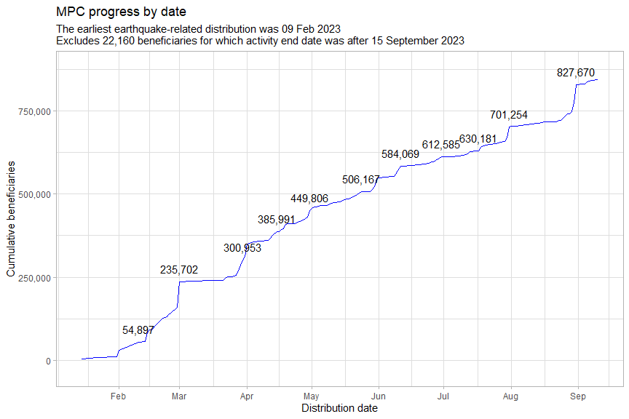

The small number of beneficiaries reached earlier than February all pertained to the HRP, the only such beneficiaries reported so far. The CWG would like to encourage partners to report on their January achievements.

# 2. Map of activities

This is a static version of the original interactive plot, which can be accessed [here](https://northwest-syria-cash-working-group.github.io/cash_reporting_20230915/#map-of-activities).

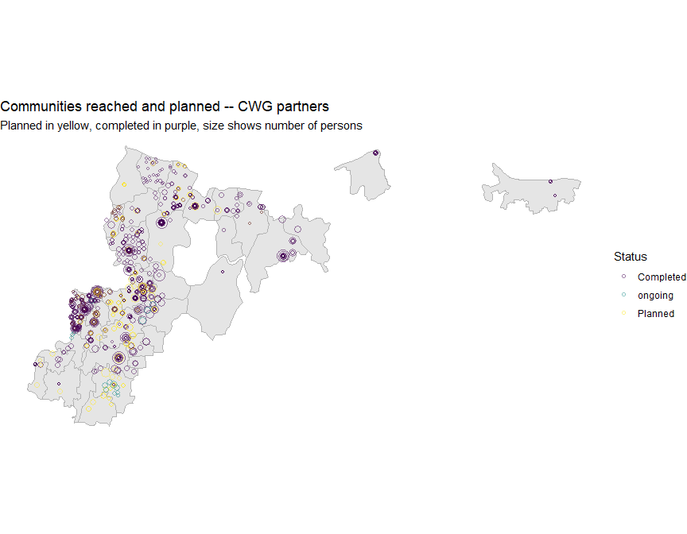

# 3. Geographic breakdown of beneficiaries

Coverage continues to be highest in Afrin and Harim districts, where the highest numbers of damaged houses and wounded people are located (though these areas do not necessarily have the highest proportions of damage).

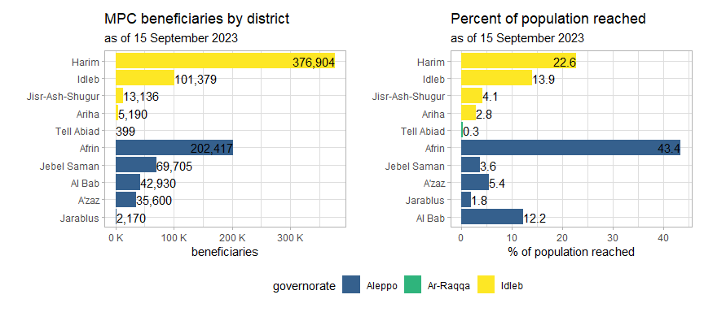

Casualties and damaged houses, absolute figures and per 100,000 persons

| **governorate** | **district** | **wounded_dead1** | **wounded_dead_100k1** | **damaged_houses1** | **damaged_houses_100k1** |
| --- | --- | --- | --- | --- | --- |
| Aleppo | A'zaz | 356 | 57.87 | 276 | 44.86 |
| Aleppo | Afrin | 2,232 | 478.79 | 2,910 | 624.22 |
| Aleppo | Al Bab | 206 | 70.04 | 832 | 282.89 |
| Aleppo | Jarablus | 40 | 33.82 | 257 | 217.30 |
| Aleppo | Jebel Saman | 616 | 236.80 | 176 | 67.66 |
| Idleb | Harim | 8,449 | 507.65 | 3,230 | 194.07 |
| Idleb | Idleb | 350 | 48.23 | 946 | 130.37 |
| Idleb | Jisr-Ash-Shugur | 595 | 183.68 | 1,915 | 591.18 |
| 1Data from the Assistance Coordination Unit, Syria 20230328; | | | | | |

Below is a breakdown of beneficiaries based on whether they originate from camps or villages. The majority of MPC beneficiaries are from villages.

More than twice as many beneficiaries from villages as from camps

| **village_camps** | **beneficiaries** | **%_beneficiaries** |
| --- | --- | --- |
| camp | 117,579 | 13.84 |
| village | 255,867 | 30.11 |
| NA | 476,384 | 56.06 |

### 3.1 By sub-district

The plots below show the breakdown of beneficiaries by sub-district. Caution must be taken to ensure that allocations are fair across the affected areas: there are numerous sub-districts where a very large proportion of the total population has already been reached by multipurpose cash, in particular, Jandairis, Harim, Salqin and Sharan.

Response activities must be proportional with the magnitude and severity of earthquake damage. Over allocation deprives affected persons of the aid they are due.

The average percentage of the population reached, of all sub-districts, is 13.7%.

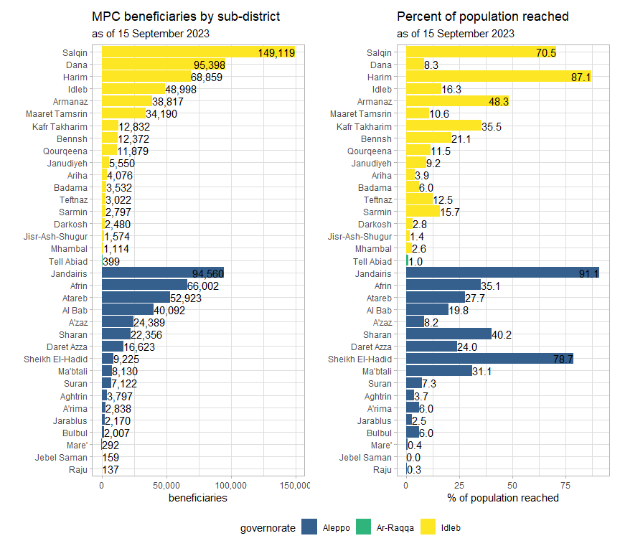

### 3.2 Planned activities

Whilst it is heartening to see new sub-districts, the majority of planned allocations have been accorded to areas that have already received relatively high levels of support.

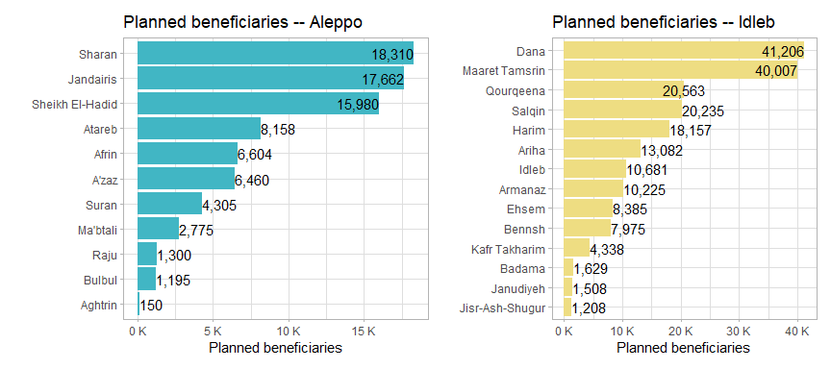

# 4. Cash response actors and cash disbursed

USD **27.3 million** has been distributed across **266** communities and **35** sub-districts in NW Syria.

Reach and footprint of cash response actors

| **implementing_partner1** | **beneficiary_freq** | **districts** | **communities** |
| --- | --- | --- | --- |
| GOAL (GOAL) | 208,321 | 4 | 96 |
| Shafak Organization (SO) | 138,430 | 8 | 43 |
| International Rescue Committee (IRC) | 130,726 | 4 | 30 |
| Ihsan for Relief and Development (IRD) | 82,998 | 6 | 40 |
| Syria Relief (SR) | 49,390 | 4 | 12 |
| Violet Organization (VO) | 46,855 | 5 | 38 |
| Bahar Organization (BO) | 36,985 | 2 | 24 |
| Norwegian Refugee Council (NRC) | 29,370 | 2 | 4 |
| Takaful Al Sham (TAS) | 28,370 | 1 | 21 |
| Ataa Humanitarian Relief Association (ATAA) | 27,434 | 9 | 25 |
| Mercy Without Limits (MWL) | 15,422 | 4 | 7 |
| Solidarités International (SI) | 14,894 | 1 | 6 |
| People in Need (PIN) | 12,804 | 5 | 6 |
| CBRTWG-031 | 12,091 | 4 | 12 |
| World Vision International (WVI) | 12,048 | 1 | 4 |
| Uluslararasi Insani Yardimlasma Dernegi (IYD) | 11,449 | 4 | 16 |
| Syrian Association for Relief and Development (SARD) | 10,693 | 3 | 10 |
| GMO -- Mercy Corps | 8,709 | 1 | 1 |
| International Humanitarian Relief (IHR) | 6,654 | 3 | 9 |
| Hand in Hand For Syria (HIHFS) | 6,651 | 1 | 7 |
| Elaf for Relief and Development (ELAF) | 5,350 | 3 | 4 |
| Hope Revival Organization (HRO) | 4,850 | 1 | 18 |
| Welthungerhilfe (WHH) | 4,830 | 4 | 4 |
| Ghiras Al Nahda (GAN) | 3,050 | 1 | 2 |
| Bonyan Organization (BO) | 2,951 | 1 | 4 |
| The Syrian Est. for Human Care and Development (Massrat) | 2,692 | 3 | 3 |
| Al-Sham Humanitarian Foundation (AHF) | 1,980 | 7 | 7 |
| Seeds Of Hope Relief and Development (SOH) | 481 | 1 | 1 |
| 1Only partners who provided more than USD 100/family/month; | | | |

In the scatter plot below, each point is a single cash working group partner. The x-axis indicates the number of beneficiary frequencies reached per agency and the y-axis indicates the number of communities (admin4) reached. Mouse over each point for more details.

This is a static version of the original interactive plot, which can be accessed [in this section](https://northwest-syria-cash-working-group.github.io/cash_reporting_20230915/#cash-response-actors-and-cash-disbursed).

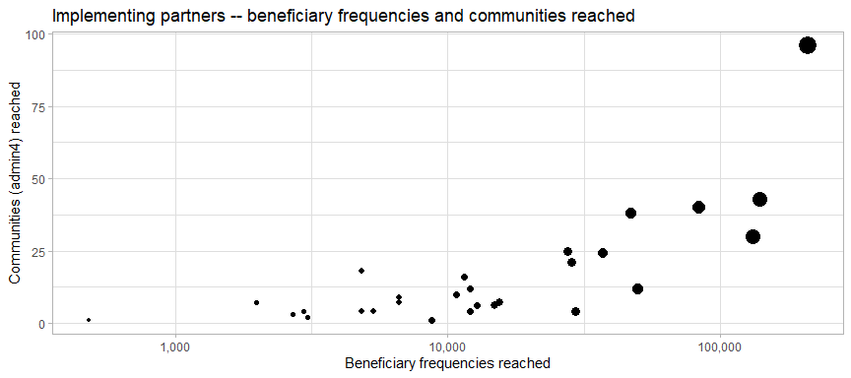

### 4.1 Cash disbursed per partner

Cash disbursed and families reached by partner

| **implementing_partner** | **total_usd** | **families** | **usd_per_fam** | **%_usd_total** |
| --- | --- | --- | --- | --- |
| GOAL (GOAL) | 6,463,650 | 43,091 | 150.00 | 23.71 |
| Shafak Organization (SO) | 4,177,350 | 27,711 | 150.75 | 15.33 |
| International Rescue Committee (IRC) | 3,496,750 | 23,562 | 148.41 | 12.83 |
| Ihsan for Relief and Development (IRD) | 2,340,900 | 16,040 | 145.94 | 8.59 |
| Syria Relief (SR) | 1,552,158 | 9,796 | 158.45 | 5.69 |
| Violet Organization (VO) | 1,421,250 | 9,680 | 146.82 | 5.21 |
| Ataa Humanitarian Relief Association (ATAA) | 1,154,929 | 6,323 | 182.66 | 4.24 |
| Bahar Organization (BO) | 944,550 | 7,397 | 127.69 | 3.47 |
| Takaful Al Sham (TAS) | 796,300 | 5,642 | 141.14 | 2.92 |
| Norwegian Refugee Council (NRC) | 754,800 | 5,427 | 139.08 | 2.77 |
| People in Need (PIN) | 411,450 | 2,743 | 150.00 | 1.51 |
| Mercy Without Limits (MWL) | 399,731 | 2,877 | 138.94 | 1.47 |
| Syrian Association for Relief and Development (SARD) | 392,148 | 2,397 | 163.60 | 1.44 |
| Uluslararasi Insani Yardimlasma Dernegi (IYD) | 375,000 | 2,500 | 150.00 | 1.38 |
| CBRTWG-031 | 362,550 | 2,417 | 150.00 | 1.33 |
| Solidarités International (SI) | 361,150 | 2,884 | 125.23 | 1.33 |
| Welthungerhilfe (WHH) | 344,400 | 2,296 | 150.00 | 1.26 |
| World Vision International (WVI) | 301,200 | 2,008 | 150.00 | 1.11 |
| Hand in Hand For Syria (HIHFS) | 210,079 | 1,400 | 150.06 | 0.77 |
| Elaf for Relief and Development (ELAF) | 207,500 | 950 | 218.42 | 0.76 |
| International Humanitarian Relief (IHR) | 179,250 | 1,195 | 150.00 | 0.66 |
| GMO -- Mercy Corps | 142,500 | 1,425 | 100.00 | 0.52 |
| Hope Revival Organization (HRO) | 121,250 | 970 | 125.00 | 0.44 |
| Bonyan Organization (BO) | 119,964 | 575 | 208.63 | 0.44 |
| Ghiras Al Nahda (GAN) | 91,500 | 610 | 150.00 | 0.34 |
| The Syrian Est. for Human Care and Development (Massrat) | 81,000 | 540 | 150.00 | 0.30 |
| Al-Sham Humanitarian Foundation (AHF) | 41,250 | 330 | 125.00 | 0.15 |
| Seeds Of Hope Relief and Development (SOH) | 11,100 | 111 | 100.00 | 0.04 |

The CWG is currently working with other Clusters to consolidate all cash-based activities and will soon be able to provide more comprehensive reporting.

### 4.2 Currency disbursed

A total of **95.82%** of cash disbursed was in USD.

Proportion of cash disbursed by currency

| **currency** | **total_usd** | **%_of_total** |
| --- | --- | --- |
| TRY | 1,138,914 | 4.18 |
| USD | 26,116,744 | 95.82 |
| Total | 27,255,658 | 100.00 |

# 5. Annexes

### 5.1 Interactive reference table at sub-district level

Columns include: governorate, district, sub-district, total population, beneficiaries, total usd disbursed, wounded and dead, wounded and dead per 100k, damaged houses, damaged houses per 100k, admin3pcode

This interactive table does not work in a PDF. Please access it online [here](https://northwest-syria-cash-working-group.github.io/cash_reporting_20230915/#interactive-reference-table-at-sub-district-level).

### 5.2 Reporting quality

This section documents issues encountered in the cleaning of 4W and FSL data and their impacts on the quality of reporting the CWG can provide. The recommendations by the CWG are included to enhance reporting quality:

1. The CWG has adopted a new 4Ws template for monthly reporting, aiming to improve the documentation of the earthquake response efforts. **The reporting deadline is set on the 15th of each month.** In February 7 partners reported their achievements, In March 9 partners have reported their achievements, with 14 partners having reported in April, in May 15 partners have reported. 9 partners have reported in June, with 11 partners have reported in July, while 14 reported in August, and 6 reported in September. If no MPC activities were implemented, please inform the CWG as well.
2. For this reporting period, activities pertaining to 22,160 beneficiaries were missing their dates or had dates in unreadable formats. **Please ensure that the start date and end date are entered in the format (mm/dd/yyyy) and select the month of reporting from the options in the drop down menu.**
3. For sex-and-age dis-aggregations, please do not back fill these columns using calculations based on the census or the MSNA. If no dis-aggregated data is available to your organisation, please leave these columns blank.
4. The Cash Working Group is currently only collecting planned and implemented **Multipurpose Cash** achievements. Whilst the CWG welcomes additional inputs on other CVA activities, we also want to ensure that the reporting load is as low as possible for partners i.e. if an agency has implemented Cash-for-Work, this should be reported to the ERL Cluster. The CWG will work with all Clusters to develop a consolidated picture of response-wide CVA interventions.
5. Please indicate in the previously_assisted column whether or not beneficiaries have been reached before. However, if the beneficiaries are being reported for the first time to the Cash Working Group, even if you have reached them before, please indicate No in this column. This column is used calculate to the number of unique individuals reached.